Monthly Status Report – August 2026
Millbrook Solar & Storage
Liam McAllister · 02 September 2026 · MB-PM-RPT-202608
Area | RAG | Comment
Overall | Green | The council consultation closed on 6 August with 143 representations.
Cost | Green | Development spend EUR 2.48 m of EUR 3.10 m budget (80 %)
Schedule | Amber | Planning decision Q1 2027 – on track
Stakeholders | Green | Consultations held: 2 of 3

Summary
The council consultation closed on 6 August with 143 representations. Natural England raised no objection subject to conditions. SunForge EPC Ltd was selected as preferred bidder.

Key figures
Metric | Value
Capex estimate (P50) | EUR 78.0 m
Open risks | 16
Consultation responses to date | 299
Development spend to date | EUR 2.48 m

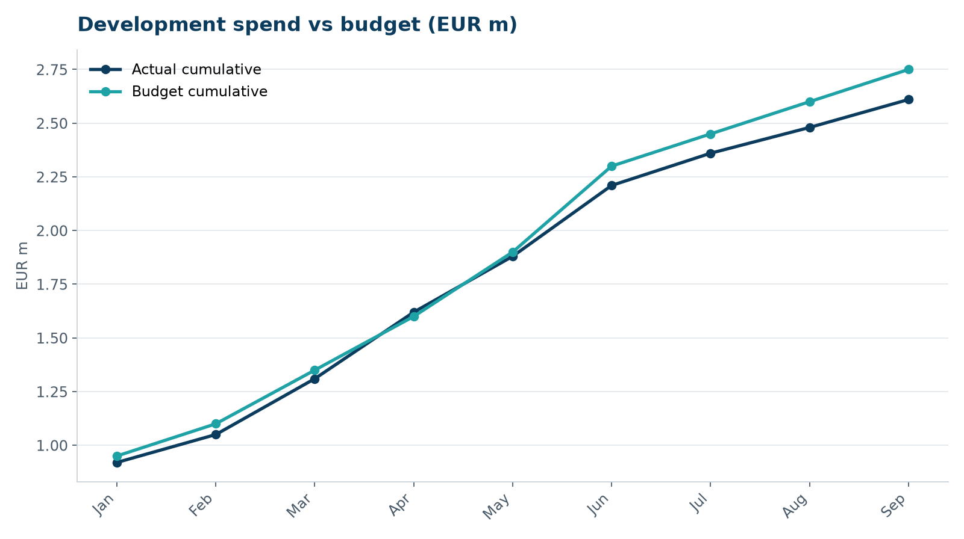
Development spend vs budget

Next month
- Consultation #3 on 16 September
- Preferred bidder letter to SunForge
- Outline BSMP to fire service

